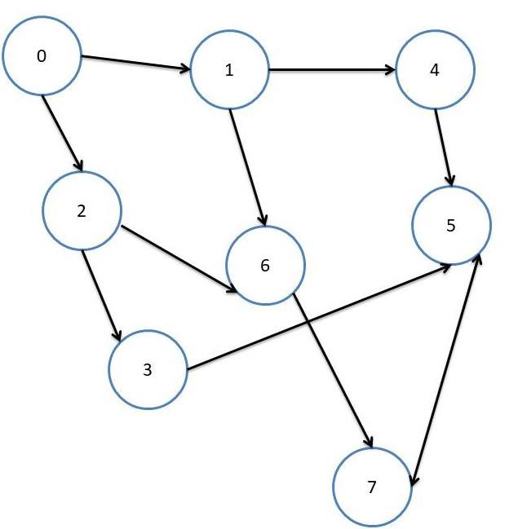

1.Start from 0:

Visited:

|  |  |  |  |  |  |  |  |
| --- | --- | --- | --- | --- | --- | --- | --- |
| 0 | 1 | 2 | 3 | 4 | 5 | 6 | 7 |
| 1 | 0 | 0 | 0 | 0 | 0 | 0 | 0 |

Queue:

|  |  |  |  |  |  |  |  |
| --- | --- | --- | --- | --- | --- | --- | --- |
| 0 |  |  |  |  |  |  |  |

Print:

|  |  |  |  |  |  |  |  |
| --- | --- | --- | --- | --- | --- | --- | --- |
|  |  |  |  |  |  |  |  |

2.

Visited:

|  |  |  |  |  |  |  |  |
| --- | --- | --- | --- | --- | --- | --- | --- |
| 0 | 1 | 2 | 3 | 4 | 5 | 6 | 7 |
| 1 | 1 | 0 | 0 | 0 | 0 | 0 | 0 |

Queue:

|  |  |  |  |  |  |  |  |
| --- | --- | --- | --- | --- | --- | --- | --- |
| 1 |  |  |  |  |  |  |  |

Print:

|  |  |  |  |  |  |  |  |
| --- | --- | --- | --- | --- | --- | --- | --- |
| 0 |  |  |  |  |  |  |  |

3.

Visited:

|  |  |  |  |  |  |  |  |
| --- | --- | --- | --- | --- | --- | --- | --- |
| 0 | 1 | 2 | 3 | 4 | 5 | 6 | 7 |
| 1 | 1 | 0 | 0 | 1 | 0 | 0 | 0 |

Queue:

|  |  |  |  |  |  |  |  |
| --- | --- | --- | --- | --- | --- | --- | --- |
| 4 |  |  |  |  |  |  |  |

Print:

|  |  |  |  |  |  |  |  |
| --- | --- | --- | --- | --- | --- | --- | --- |
| 0 | 1 |  |  |  |  |  |  |

4.

Visited:

|  |  |  |  |  |  |  |  |
| --- | --- | --- | --- | --- | --- | --- | --- |
| 0 | 1 | 2 | 3 | 4 | 5 | 6 | 7 |
| 1 | 1 | 0 | 0 | 1 | 1 | 0 | 0 |

Queue:

|  |  |  |  |  |  |  |  |
| --- | --- | --- | --- | --- | --- | --- | --- |
| 5 |  |  |  |  |  |  |  |

Print:

|  |  |  |  |  |  |  |  |
| --- | --- | --- | --- | --- | --- | --- | --- |
| 0 | 1 | 4 |  |  |  |  |  |

5.

Visited:

|  |  |  |  |  |  |  |  |
| --- | --- | --- | --- | --- | --- | --- | --- |
| 0 | 1 | 2 | 3 | 4 | 5 | 6 | 7 |
| 1 | 1 | 0 | 0 | 1 | 1 | 0 | 1 |

Queue:

|  |  |  |  |  |  |  |  |
| --- | --- | --- | --- | --- | --- | --- | --- |
| 7 |  |  |  |  |  |  |  |

Print:

|  |  |  |  |  |  |  |  |
| --- | --- | --- | --- | --- | --- | --- | --- |
| 0 | 1 | 4 | 5 |  |  |  |  |

6.

Visited:

|  |  |  |  |  |  |  |  |
| --- | --- | --- | --- | --- | --- | --- | --- |
| 0 | 1 | 2 | 3 | 4 | 5 | 6 | 7 |
| 1 | 1 | 0 | 0 | 1 | 1 | 0 | 1 |

Queue:

|  |  |  |  |  |  |  |  |
| --- | --- | --- | --- | --- | --- | --- | --- |
| 7 |  |  |  |  |  |  |  |

Print:

|  |  |  |  |  |  |  |  |
| --- | --- | --- | --- | --- | --- | --- | --- |
| 0 | 1 | 4 | 5 |  |  |  |  |

7.

Visited:

|  |  |  |  |  |  |  |  |
| --- | --- | --- | --- | --- | --- | --- | --- |
| 0 | 1 | 2 | 3 | 4 | 5 | 6 | 7 |
| 1 | 1 | 0 | 0 | 1 | 1 | 1 | 1 |

Queue:

|  |  |  |  |  |  |  |  |
| --- | --- | --- | --- | --- | --- | --- | --- |
| 6 |  |  |  |  |  |  |  |

Print:

|  |  |  |  |  |  |  |  |
| --- | --- | --- | --- | --- | --- | --- | --- |
| 0 | 1 | 4 | 5 | 7 |  |  |  |

8.

Visited:

|  |  |  |  |  |  |  |  |
| --- | --- | --- | --- | --- | --- | --- | --- |
| 0 | 1 | 2 | 3 | 4 | 5 | 6 | 7 |
| 1 | 1 | 0 | 0 | 1 | 1 | 1 | 1 |

Queue:

|  |  |  |  |  |  |  |  |
| --- | --- | --- | --- | --- | --- | --- | --- |
| 2 |  |  |  |  |  |  |  |

Print:

|  |  |  |  |  |  |  |  |
| --- | --- | --- | --- | --- | --- | --- | --- |
| 0 | 1 | 4 | 5 | 7 | 6 |  |  |

9.

Visited:

|  |  |  |  |  |  |  |  |
| --- | --- | --- | --- | --- | --- | --- | --- |
| 0 | 1 | 2 | 3 | 4 | 5 | 6 | 7 |
| 1 | 1 | 1 | 0 | 1 | 1 | 1 | 1 |

Queue:

|  |  |  |  |  |  |  |  |
| --- | --- | --- | --- | --- | --- | --- | --- |
| 3 |  |  |  |  |  |  |  |

Print:

|  |  |  |  |  |  |  |  |
| --- | --- | --- | --- | --- | --- | --- | --- |
| 0 | 1 | 4 | 5 | 7 | 6 | 2 |  |

10.

Visited:

|  |  |  |  |  |  |  |  |
| --- | --- | --- | --- | --- | --- | --- | --- |
| 0 | 1 | 2 | 3 | 4 | 5 | 6 | 7 |
| 1 | 1 | 1 | 1 | 1 | 1 | 1 | 1 |

Queue:

|  |  |  |  |  |  |  |  |
| --- | --- | --- | --- | --- | --- | --- | --- |
|  |  |  |  |  |  |  |  |

Print:

|  |  |  |  |  |  |  |  |
| --- | --- | --- | --- | --- | --- | --- | --- |
| 0 | 1 | 4 | 5 | 7 | 6 | 2 | 3 |